**Home Networking Guide**

**Hardware**

To set up a home network, you'll need a combination of hardware components like routers, switches, network interface cards (NICs), and cables. Each piece plays an important role in the transfer and management.

**Wireless vs. Wired**

Wired connections are typically faster and more stable, using Ethernet cables. Wireless (Wi-Fi) provides more convenience and flexibility but may be subject to interference or signal degradation over distances. 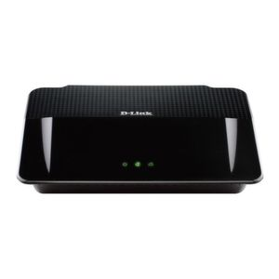

**Adapters**

Network adapters allow computers and devices to connect to a network. These can be built-in or external USB devices that enable connectivity through wireless or Ethernet.

Modern Routers

Routers are the heart of most home networks, managing traffic between devices and the internet. Many include built-in firewalls and support dual-band Wi-Fi to reduce interference.

Powerline Adapters

These adapters use your home's electrical wiring to extend your network, ideal for places where Wi-Fi signals are weak.

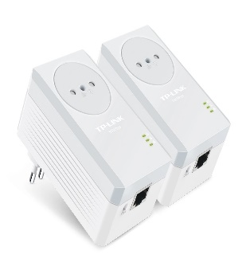

[This Photo](https://www.tecnomani.com/i-15-migliori-adattatori-powerline-del-2015/) by Unknown Author is licensed under [CC BY-NC-ND](https://creativecommons.org/licenses/by-nc-nd/3.0/)

***Wireless (Wi-Fi) Standards***

Wi-Fi standards like 802.11n, 802.11ac, and 802.11ax (Wi-Fi 6) determine the speed and range of your wireless connection. When setting up your network, ensure your router and devices support the latest standards for best performance.